This file: Z:\CenterMATLAB\Script to create histogram of values from images.

Run the path file by executing

>> addpath('Z:\CenterMATLAB') : run (toolbox_path)

Click yes twice.

Open up pvGUi

>>pvGUI

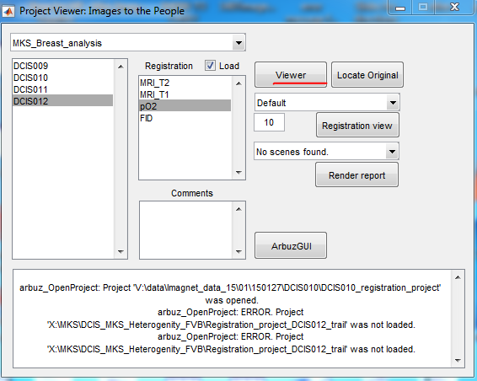

Find the project and experiment you are interested. Highlight the pO2 image. Click the viewer button to launch ibGUI.

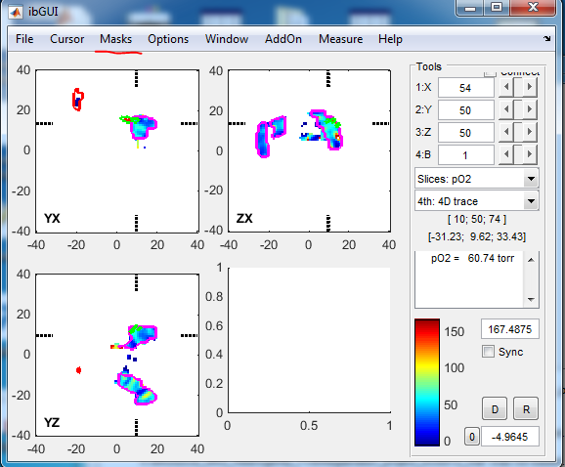

Now click on Masks >>Mask toolbar. The window called mask settings is here:

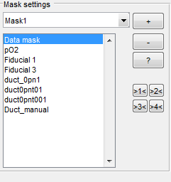

All masks associated with this image will be in the list in this box. Take note of the order of those masks.

Go to File > export.

Then execute this code:

Image = export.Images{1}.Image;

for ii = 1: size(export.Masks,2)

figure

hist(Image(find(export.Masks{ii}.Mask == 1& Image ~= -100 )),100);

title(export.Masks{ii}.Name)

xlabel ('pO2');

ylabel ('Voxel Counts');

end

Find the histogram with the title you want. Close the others.

By changing 100 in the above code you can alter the number of bins in the histogram. And if you decide you only need one of the masks turned into a histogram change 1: size(export.Masks,2) to the number of the histogram (from the mask list) you do want.

If you want any of the normal statistics from these datasets. Execute the following code.

Image = export.Images{1}.Image;

for ii = 1: size(export.Masks,2)

idx = find(export.Masks{ii}.Mask == 1& Image ~= -100 & Image ~= 0 );

data = Image(idx);

name =export.Masks{ii}.Name

mean_of_mask = mean(data)

median_of_mask = median(data)

standard_dev = std(data)

end